1. INTRODUCTION

1.1 Project Overview
AutoSage App Using Gemini Flash is an AI-powered vehicle information and decision-support platform designed to help users explore, compare, and evaluate two-wheelers and four-wheelers. The application leverages Gemini Flash technology to provide real-time specifications, reviews, maintenance insights, and eco-friendly vehicle recommendations. With rapid advancements in automotive technology, increasing electric vehicle adoption, and frequent model launches, users often struggle to access structured, reliable, and up-to-date vehicle information. AutoSage addresses this problem by transforming scattered automotive data into intelligent insights that support better vehicle purchasing and maintenance decisions.
- Goals:
- Provide an AI-powered platform for vehicle comparison and insights.
- Help users make informed decisions while purchasing vehicles.
- Offer maintenance guidance for improved safety and longevity.
- Promote eco-friendly vehicle awareness and sustainability.
- Features:
- Vehicle Specification Analyzer
Provides detailed specifications including engine type, mileage, torque, power, fuel type, and price.
- AI-Based Vehicle Comparison Tool
Compares multiple vehicles based on performance, features, price, and user preferences.
- Maintenance Advisory System
Provides seasonal and condition-based maintenance alerts.
- Eco-Friendly Vehicle Insights
Suggests electric and hybrid vehicles with environmental impact data.
- Real-Time Trend Updates
Displays the latest launches, automotive trends, and user reviews.

2.IDEATION PHASE
2.1 Brainstorm & Idea Prioritization Template
Date | 28 January 2026
Team ID | LTVIP2026TMIDS55232
Project Name | AutoSage App Using Gemini Flash
Maximum Marks | 4 Marks

Brainstorming is a creative process where a group generates potential solutions, suggestions, or innovative ideas for a specific problem or project. After generating ideas, participants prioritize them based on feasibility, impact, cost, and strategic importance to determine which ideas should be implemented.

Brainstorming for AutoSage App Using Gemini Flash
The ideation phase of AutoSage focused on identifying real-world problems faced by vehicle buyers and owners, such as:
- Scattered and unreliable vehicle information
- Difficulty comparing two-wheelers and four-wheelers
- Lack of personalized recommendations
- Limited awareness about eco-friendly vehicles
- Forgetting maintenance schedules
- No intelligent assistant for vehicle queries
The brainstorming sessions involved discussions among developers, AI enthusiasts, automotive researchers, and end-user representatives. The team explored ideas such as:
- AI-powered vehicle comparison engine
- Real-time vehicle specification analyzer
- Smart maintenance advisory system
- Eco-friendly vehicle recommendation tool
- Budget-based vehicle filtering
- Natural language query handling using Gemini Flash
The core idea prioritized was developing an AI-driven vehicle assistant that transforms raw automotive data into structured, intelligent insights for users.

Step-1: Team Gathering, Collaboration & Problem Selection
To initiate the AutoSage project, a multidisciplinary team was formed with expertise in:
- Software development
- Artificial Intelligence
- Web technologies
- Automotive research
Multiple brainstorming and discussion sessions were conducted to understand current challenges in the vehicle buying and maintenance process. The team analyzed:
- Online vehicle comparison platforms
- Automotive blogs and review portals
- User feedback and common buying difficulties
During discussions, the team identified that users often rely on multiple websites and manual comparisons to choose vehicles. There is no unified AI-powered system that provides intelligent, real-time, and personalized vehicle insights.
Thus, the main problem identified was:
“Users lack a centralized, AI-driven platform that provides accurate vehicle comparisons, smart recommendations, and proactive maintenance guidance.”

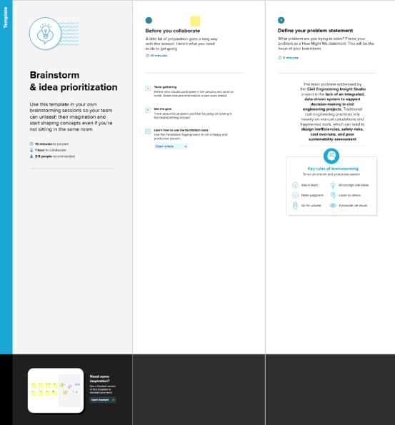

Step-2: Brainstorm, Idea Listing and Grouping
In this phase, the team generated multiple ideas related to solving real-world challenges faced by vehicle buyers and owners. All ideas were listed and then grouped based on similarity and purpose.
The ideas were categorized into the following groups:

Vehicle Information & Comparison
- Detailed vehicle specifications viewer
- Side-by-side comparison tool
- Price and feature filtering
- Latest vehicle launch updates

AI & Smart Assistance
- Natural language vehicle queries
- Personalized vehicle recommendations
- Budget-based suggestions
- AI-generated pros and cons

Maintenance & Safety
- Seasonal maintenance alerts
- Service reminders
- Safety tips and performance guidance

Sustainability & Eco-Friendly Vehicles
- Electric and hybrid vehicle insights
- Environmental impact analysis
- Government subsidy and incentive information
By grouping these ideas, the team identified the most impactful features that align with user needs and technical feasibility.

Step-3: Idea Prioritization
Idea prioritization is the process of ranking ideas based on feasibility, impact, cost, innovation, and strategic importance to determine which features should be implemented first. 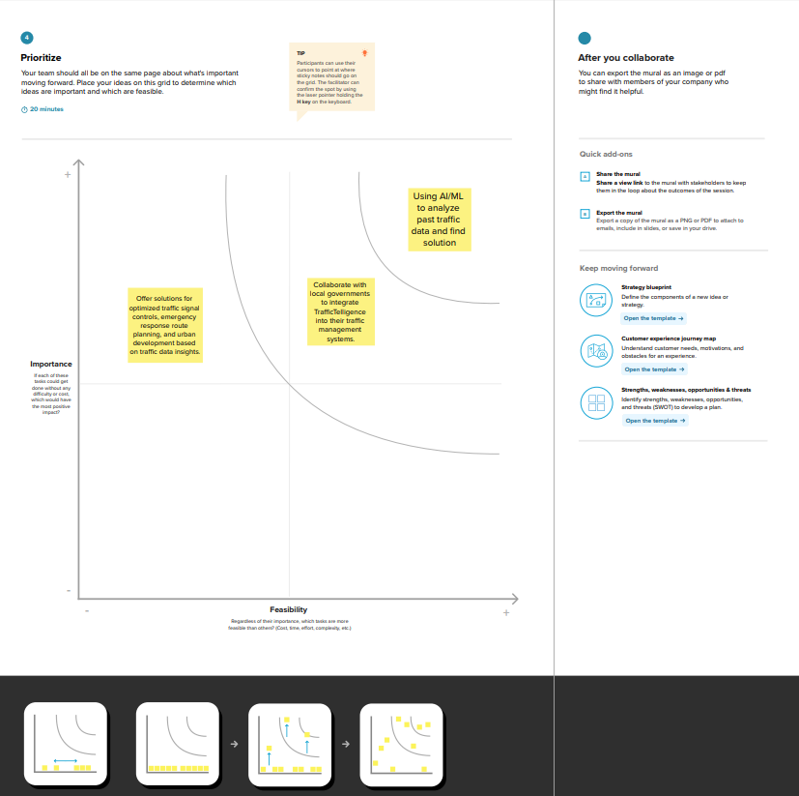
After evaluating all ideas, the team decided to prioritize the integration of AI and data analytics using Gemini Flash to:
- Analyze vehicle specifications
- Generate intelligent comparisons
- Provide personalized recommendations
- Answer user queries in natural language
The second key idea involves collaborating with automobile dealerships and automotive data providers to integrate real-time vehicle data into the AutoSage platform, ensuring accuracy and practical usability.
The next focus is extending the system to support:
- Advanced AI-based vehicle recommendation models
- Predictive maintenance alerts
- Smart eco-friendly vehicle suggestion systems
These prioritized ideas ensure innovation, user impact, and scalability.

2.2 Empathize & Discover
Date | 28 January 2026
Team ID | LTVIP2026TMIDS55232
Project Name | AutoSage App Using Gemini Flash
Maximum Marks | 4 Marks

Empathy Map Canvas:
An empathy map is a simple and easy-to-understand visual tool that captures knowledge about users’ behaviors, thoughts, feelings, and challenges. It helps the development team better understand users and design solutions from their perspective.
Creating an effective solution requires identifying the real problem and understanding the person experiencing it. The empathy mapping exercise encourages the team to think from the user's point of view, considering their goals, frustrations, expectations, and decision-making process.

AutoSage App Using Gemini Flash
In today’s automotive market, vehicle buyers and owners face several challenges. Rapid technological advancements, increasing electric vehicle adoption, and frequent model launches have made the vehicle selection process complex. Users often struggle with comparing multiple options, understanding technical specifications, and identifying budget-friendly or eco-friendly vehicles.
Many users rely on multiple websites, YouTube reviews, and dealership visits to gather information. This process is time-consuming, confusing, and sometimes misleading. Additionally, vehicle owners often forget maintenance schedules, seasonal safety checks, and performance optimization practices.
Maintaining clear visibility into vehicle specifications, price comparisons, maintenance requirements, and environmental impact is essential for making informed decisions. Buyers want accurate, real-time, and personalized insights before purchasing a vehicle.

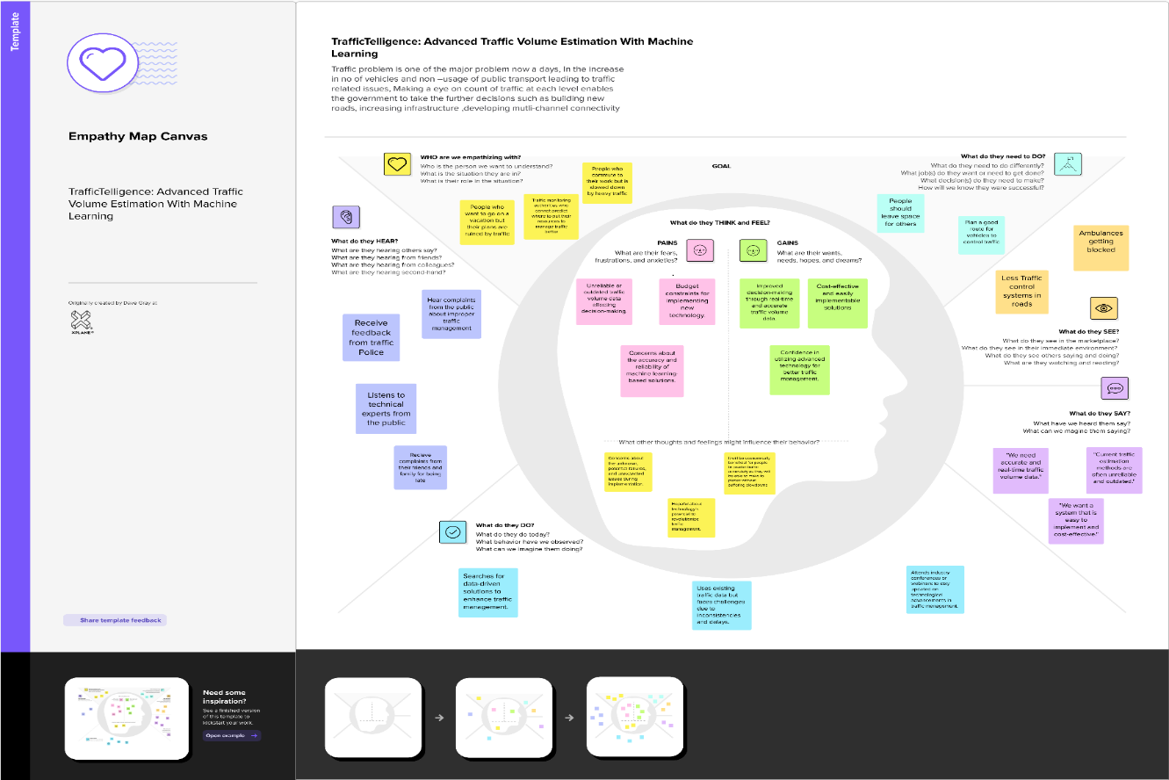

3.REQUIREMENT ANALYSIS
3.1 Solution Requirements (Functional & Non-functional)
Date | 31 January 2026
Team ID | LTVIP2026TMIDS55232
Project Name | AutoSage App Using Gemini Flash
Maximum Marks | 4 Marks
3.1.1 Functional Requirements:
Following are the functional requirements of the proposed solution.

FR No. | Functional Requirement (Epic) | Sub Requirement (Story / Sub-Task)
FR-1 | Vehicle Data Preprocessing & Validation | Collect raw vehicle data (specifications, price, mileage, engine details) and convert it into a clean, structured format. Validate inputs and remove incomplete or inconsistent data.
FR-2 | AI-Based Vehicle Query & Classification | Process natural language user queries using Gemini Flash. Classify vehicles into categories such as two-wheelers, four-wheelers, electric vehicles, hybrid vehicles, petrol, and diesel models.
FR-3 | Vehicle Comparison & Performance Analysis | Compare multiple vehicles based on mileage, engine performance, price, features, and safety ratings. Generate side-by-side comparison reports.
FR-4 | Insight Generation & Reporting | Provide personalized recommendations based on budget and preferences. Generate visual and tabular reports including cost estimation, fuel efficiency, maintenance insights, and eco-impact metrics.
3.1.2 Non-functional Requirements:
Following are the non-functional requirements of the proposed solution.
FR No. | Non-Functional Requirement | Description
NFR-1 | Usability | The system should provide a simple, intuitive, and user-friendly interface that allows users to easily search, compare, and analyze vehicle information
NFR-2 | Security | User preferences, search history, and vehicle data should be securely stored and transmitted using encryption to prevent unauthorized access.
NFR-3 | Reliability | The system should consistently generate accurate vehicle information, comparisons, and AI-based responses without errors or inconsistencies.
NFR-4 | Performance | The Gemini Flash AI model should process user queries and generate responses in near real-time with minimal latency.
NFR-5 | Availability | The system should be accessible 24/7 with minimal downtime to ensure continuous access to vehicle information and recommendations.

3.2 Data Flow Diagram & User Stories
Date | 31 January 2026
Team ID | LTVIP2026TMIDS55232
Project Name | AutoSage App Using Gemini Flash
Maximum Marks | 4 Marks
Data Flow Diagrams:
A Data Flow Diagram (DFD) is a traditional visual representation of the information flows within a system. A neat and clear DFD can depict the right amount of the system requirement graphically. It shows how data enters and leaves the system, what changes the information, and where data is stored.

Flow Diagram:

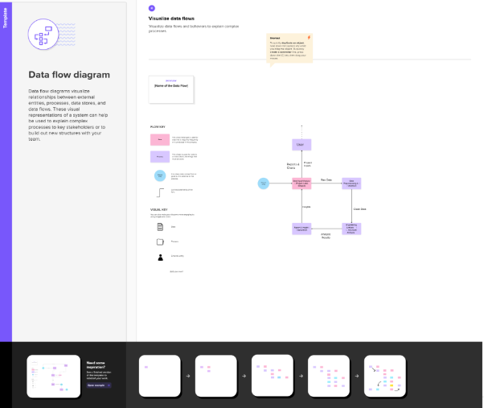

3.2.2 User Stories
Use the below template to list all the user stories for the product
User Type | Functional Requirement (Epic) | User  Story  Number | User Story / Task | Acceptance criteria | Priority | Release
Vehicle Buyer | Intelligent Vehicle Recommendation | USN-1 | As a vehicle buyer, I want AI-based personalized vehicle suggestions based on my budget, fuel preference, and usage needs so that I can choose the best vehicle. | System processes natural language queries using Gemini Flash and provides accurate, relevant vehicle recommendations based on user preferences. | High | Sprint 1
Car Owner | Maintenance Advisory & Alerts | USN-2 | As a vehicle owner, I want maintenance reminders and service suggestions so that I can maintain my vehicle properly. | System generates periodic maintenance alerts based on vehicle type and usage conditions. Notifications are clearly displayed. | High | Sprint 1
Automtive Analyst | Advanced Vehicle Comparison | USN-3 | As an automotive analyst, I want detailed comparison reports including price trends, mileage, performance metrics, and feature analysis. | Reports display structured comparison tables and visual insights across multiple vehicles. | Medium | Sprint 2
System Developer | AI Model Integration | USN-4 | As a system developer, I want to integrate Gemini Flash API into the platform for intelligent query processing and response generation. | Gemini Flash API integration works reliably with validated outputs and proper documentation for maintenance. | High | Sprint 2
Eco-Conscious User | Sustainable Vehicle Insights | USN-5 | As an eco-conscious user, I want insights on electric and hybrid vehicles including environmental impact comparisons. | System provides emission data, efficiency comparisons, and sustainability indicators for selected vehicles. | High | Sprint 3
First-Time Buyer | Guided Decision Support | USN-6 | As a first-time vehicle buyer, I want simplified explanations and guided recommendations so that I can understand vehicle specifications easily. | System presents easy-to-understand explanations of technical terms and structured decision suggestions. | medium | Sprint 4
QA Engineer | Testing & Quality Assurance | USN-7 | As a QA Engineer, I want to test AI modules, comparison features, and dashboards to ensure system accuracy and usability. | All modules function correctly with validated outputs, minimal errors, and consistent UI behavior after testing. | medium | Sprint 5

3.3 Technology Stack (Architecture & Stack)
Date | 31 January 2026
Team ID | LTVIP2026TMIDS55232
Project Name | AutoSage App Using Gemini Flash
Maximum Marks | 4 Marks
Technical Architecture:
The Deliverable shall include the architectural diagram as below and the information as follows:
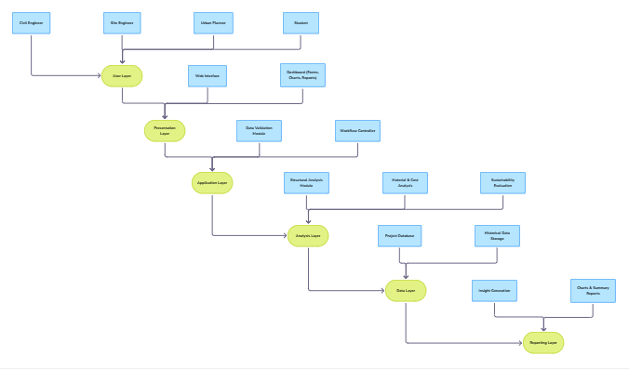
Table-1 : Components & Technologies:
S.No | Component | Description | Technology
1. | User Layer | End users such as vehicle buyers, car owners, automotive analysts, and eco-conscious users interact with the system to search, compare, and analyze vehicles. | Web Browser
2. | Presentation Layer | Provides a user-friendly interface for entering vehicle preferences, asking AI queries, and viewing comparison results and maintenance alerts. | HTML  CSS  JavaScript
3. | Application Layer | Validates user inputs, processes user queries, and manages communication between the frontend, AI engine, and database. | Python  Flask (Web Framework)
4. | Analysis Layer | Core component where natural language queries are processed and intelligent vehicle recommendations are generated using Gemini Flash. | Python  Gemini Flash API
5. | Data Layer | Stores vehicle specifications, comparison results, user preferences, and historical query data. | CSV files  Local storage / File system
6. | Report Layer | Generates vehicle comparison charts, sustainability indicators, and downloadable reports for decision support. | Python  Matplotlib / Charts  HTML reports

Table-2: Application Characteristics:
S.No | Characteristics | Description | Technology
1. | Open-Source Frameworks | Uses open-source technologies to reduce development cost, improve flexibility, and simplify maintenance. | Python’s Flask
2. | Scalability | The system can scale to support multiple vehicle categories such as two-wheelers, four-wheelers, electric vehicles, and hybrid models. | Modular architecture
3. | Performance | Provides fast AI-powered responses and quick vehicle comparison results for a smooth user experience. | Efficient Python logic
4. | Availability | Accessible anytime through web deployment with continuous AI support for query processing. | Local / Web deployment
5. | Usability | Simple and intuitive interface suitable for first-time buyers and experienced vehicle owners. | HTML, CSS
6. | Security | Protects user preferences and vehicle data from unauthorized access through validation and controlled access mechanisms. | input validation, access control

4.PROJECT DESIGN

4.1 Problem – Solution Fit Template

Date | 2nd February 2026
Team ID | LTVIP2026TMIDS55232
Project Name | AutoSage App Using Gemini Flash
Maximum Marks | 2 Marks

Problem – Solution Fit Template:
The Problem-Solution Fit simply means that you have found a problem with your customer and that the solution you have realized for it actually solves the customer’s problem. It helps entrepreneurs, marketers and corporate innovators identify behavioral patterns and recognize what would work and why
Purpose:
- Solve complex problems in a way that fits the state of your customers.
- Succeed faster and increase your solution adoption by tapping into existing mediums and channels of behavior.
- Sharpen your communication and marketing strategy with the right triggers and messaging.
- Increase touch-points with your company by finding the right problem-behavior fit and building trust by solving frequent annoyances, or urgent or costly problems.
- Understand the existing situation in order to improve it for your target group.
Template:

References:
- https://www.ideahackers.network/problem-solution-fit-canvas/
- https://medium.com/@epicantus/problem-solution-fit-canvas-aa3dd59cb4fe

4.2 Proposed Solution Template
Date | 2nd February 2026
Team ID | LTVIP2026TMIDS55232
Project Name | AutoSage App Using Gemini Flash
Maximum Marks | 2 Marks

Proposed Solution Template:
Project team shall fill the following information in proposed solution template.

S.No. | Parameter | Description
1. | Problem Statement (Problem to be  solved) | Vehicle buyers and owners face significant challenges due to the vast number of options available in the automotive market, complex technical specifications, and scattered information across multiple platforms. Users often struggle to compare vehicles effectively, understand performance metrics, evaluate eco-friendly alternatives, and maintain their vehicles properly. The absence of a centralized AI-driven system makes the decision-making process time-consuming and confusing. Therefore, there is a need to develop an intelligent, data-driven application that can analyze vehicle data, provide personalized recommendations, enable smart comparisons, and assist users in making informed purchasing and maintenance decisions.
2. | Idea / Solution description | AutoSage App Using Gemini Flash is an AI-powered vehicle assistant platform that processes vehicle specifications, pricing data, user preferences, and sustainability metrics to generate intelligent insights. The application enables users to compare two-wheelers and four-wheelers, receive AI-based recommendations, get seasonal maintenance alerts, and explore eco-friendly vehicle options through a user-friendly interface.
3. | Novelty / Uniqueness | The uniqueness of this project lies in integrating advanced AI capabilities of Gemini Flash with real-time automotive data to provide natural language query handling, intelligent comparison generation, personalized vehicle suggestions, and eco-impact analysis within a single unified platform. This reduces dependency on multiple websites and manual research.
4. | Social Impact / Customer Satisfaction | The project promotes informed and responsible vehicle purchasing decisions. It encourages adoption of electric and hybrid vehicles, enhances road safety through maintenance reminders, and improves customer confidence by providing accurate, AI-driven insights. This ultimately contributes to environmental sustainability and smarter consumer behavior.
5. | Business Model (Revenue Model) | The platform can operate on a freemium model, offering basic vehicle comparisons for free and premium AI insights through subscription plans. Additional revenue can be generated through partnerships with dealerships, affiliate marketing, vehicle insurance companies, and automotive advertisement placements.
6. | Scalability of the Solution | AutoSage is scalable and can be extended to include global vehicle databases, real-time dealership pricing integration, AI-powered loan and insurance recommendations, mobile application deployment, and cloud-based multi-user access. Future integration with smart vehicle IoT systems can further enhance personalization and predictive maintenance features.

4.3 Solution Architecture
Date | ^{5th} February 2026
Team ID | LTVIP2026TMIDS55232
Project Name | AutoSage App Using Gemini Flash
Maximum Marks | 4 Marks

Solution Architecture Overview
The AutoSage App Using Gemini Flash follows a modular and layered architecture that enables efficient vehicle data processing, AI-based analysis, and intelligent insight generation.
The system is designed to accept user queries and vehicle preferences, validate inputs, process them using Gemini Flash, and present personalized recommendations and comparisons through an interactive interface.
The architecture consists of the following layers:
- User Interface Layer – Handles user interaction
- Application Layer – Manages request handling and business logic
- AI Processing Layer – Processes queries using Gemini Flash
- Data Layer – Stores vehicle specifications and user preferences
- Insight & Reporting Layer – Generates visual insights and recommendations

- PROJECT PLANNING & SCHEDULING

5.1 Project Planning Template (Product Backlog, Sprint Planning, Stories, Story points)

Date | ^{5th} February 2026
Team ID | LTVIP2026TMIDS55232
Project Name | Civil Engineering Insight Studio
Maximum Marks | 5 Marks

Product Backlog, Sprint Schedule, and Estimation (4 Marks)
Use the below template to create product backlog and sprint schedule
Sprint | Functional Requirement (Epic) | User Story Number | User Story / Task | Story Points | Priority | Team Members
Sprint-1 | Project Setup & Infrastructure | USN-1 | Configure the development environment by setting up Python, Flask framework, frontend tools, and integrating Gemini Flash API for AutoSage App development. | 1 | Medium | Reddi Satya Indira Priyanka
Sprint-1 | Data Collection& Preprocessing | USN-2 | As a developer, I want to collect and structure vehicle specifications (price, mileage, engine type, fuel type, features) so that they can be used for AI analysis and comparison. | 2 | High | Inturi Rishyendra Nag
Sprint-2 | Analysis Module Integration | USN-3 | As a developer, I want to integrate Gemini Flash into the application to process natural language vehicle queries and generate intelligent responses. | 2 | High | Bontha Rahul Dev
Sprint-3 | Error Handling & Input Validation | USN-4 | As a user, I want to compare multiple vehicles side-by-side based on price, mileage, performance, and features so that I can choose the best option. | 2 | High | Pathan Basheer Khan

- FUNCTIONAL AND PERFORMANCE TESTING
6.1 Model Performance Test
Date | 12th February
Team ID | LTVIP2026TMIDS55232
Project Name | AutoSage App Using Gemini Flash
Maximum Marks | 10 Marks

Model Performance Testing:
Project team shall fill the following information in model performance testing template.
S.No | Performance Test Type | Description | Expected Result
 | Response Time Testing | Measures the time taken to process inputs and display analysis results. | Results are generated within acceptable time limits without delay.
 | Load Testing | Evaluates system behaviour when multiple users access the application simultaneously. | System remains stable and responsive under normal load.
 | Scalability Testing | Check’s ability to handle increased users and project data. | Performance remains consistent as usage increases.
 | Resource Utilization Testing | Monitors CPU, memory, and storage usage during analysis. | Optimal resource usage without excessive consumption.
 | Throughput Testing | Measures number of analysis requests processed per unit time. | System processes multiple requests efficiently.

7. RESULTS
7.1 Output Screenshots
The complete execution of the Civil Engineering Insight Studio application is shown below through a series of step-by-step screenshots:

Step 1: Running the Streamlit Application
- Run the app.py file from your terminal or VS Code.
- You will see the Streamlit server starting message
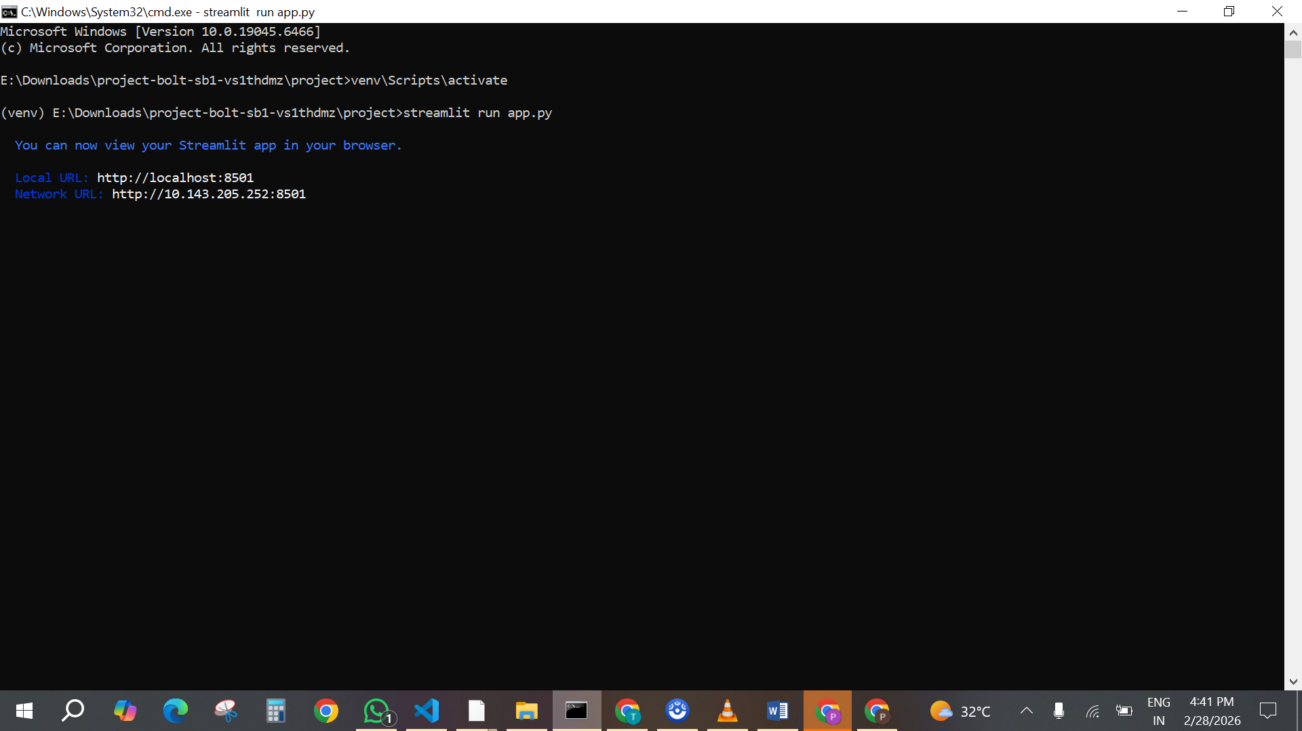
Fig 7.1.1:code running in terminal
Step 2: Opening the Application in Browser
Open your browser and navigate to:
- http://localhost:8501
The Home Page will appear with a clean and simple interface to input:
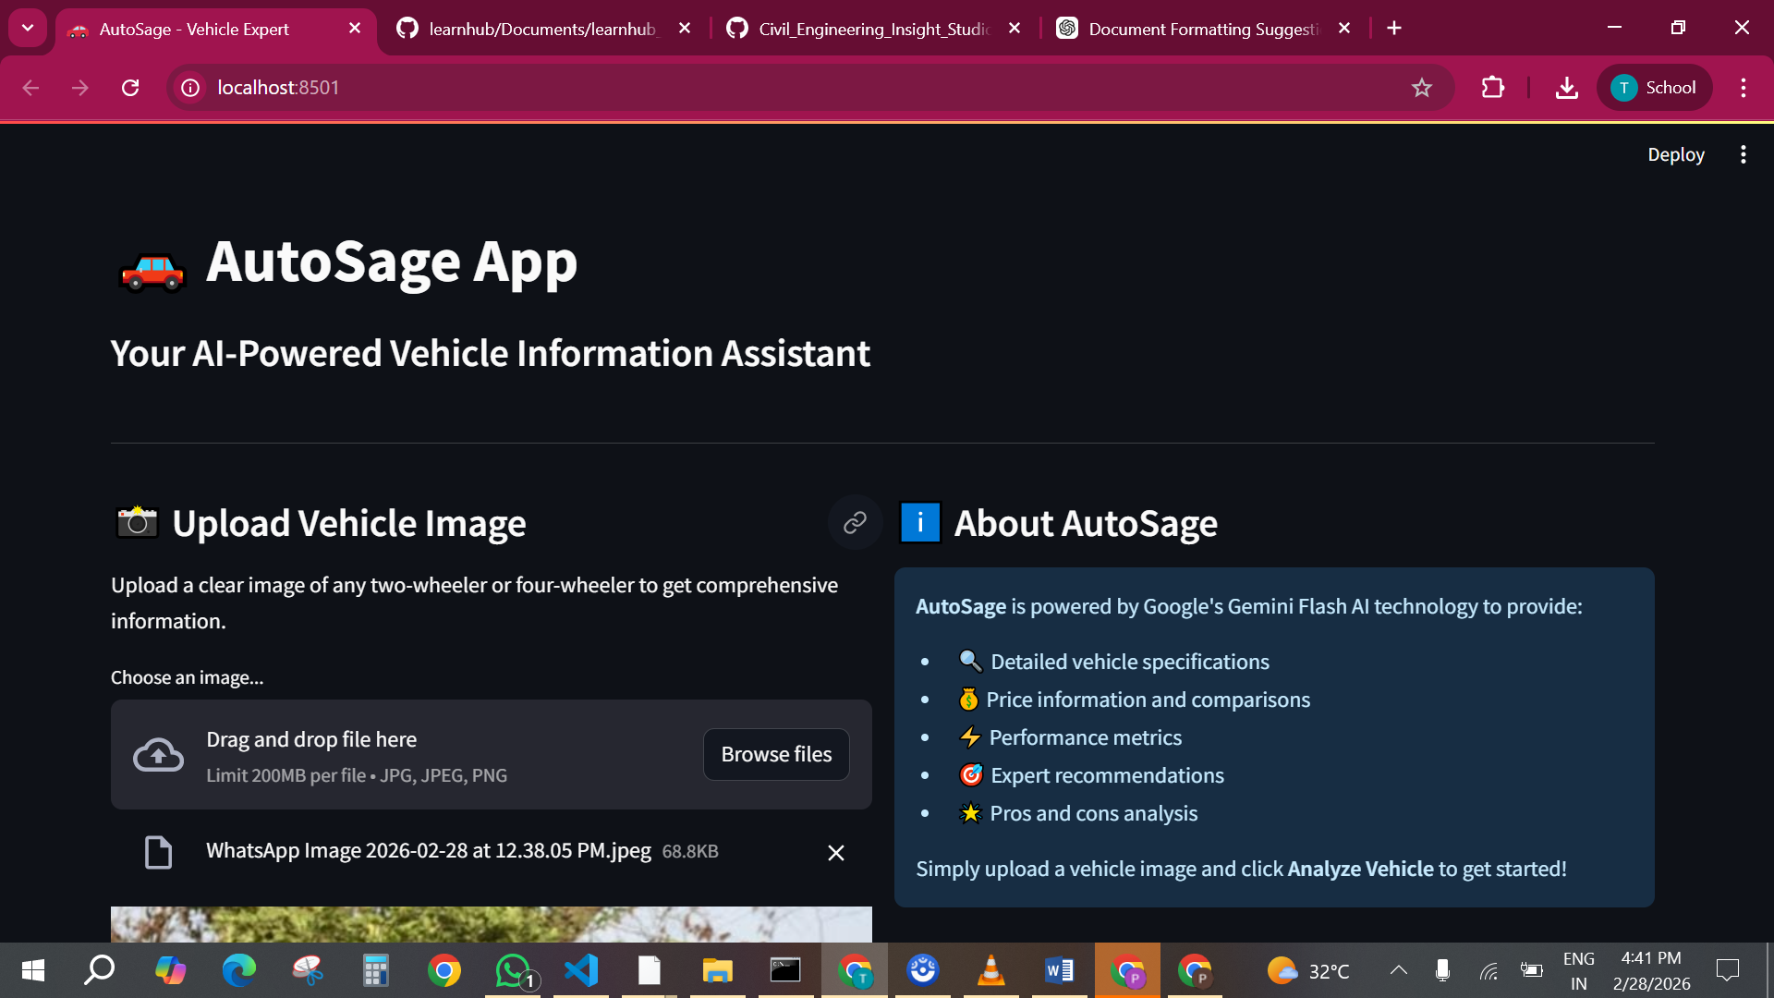
Fig 7.1.2:Home page Interface

Step 3: Submitting the Form for Prediction
- Drag the image click enter.
- The backend processes the request using the trained model and encoder.
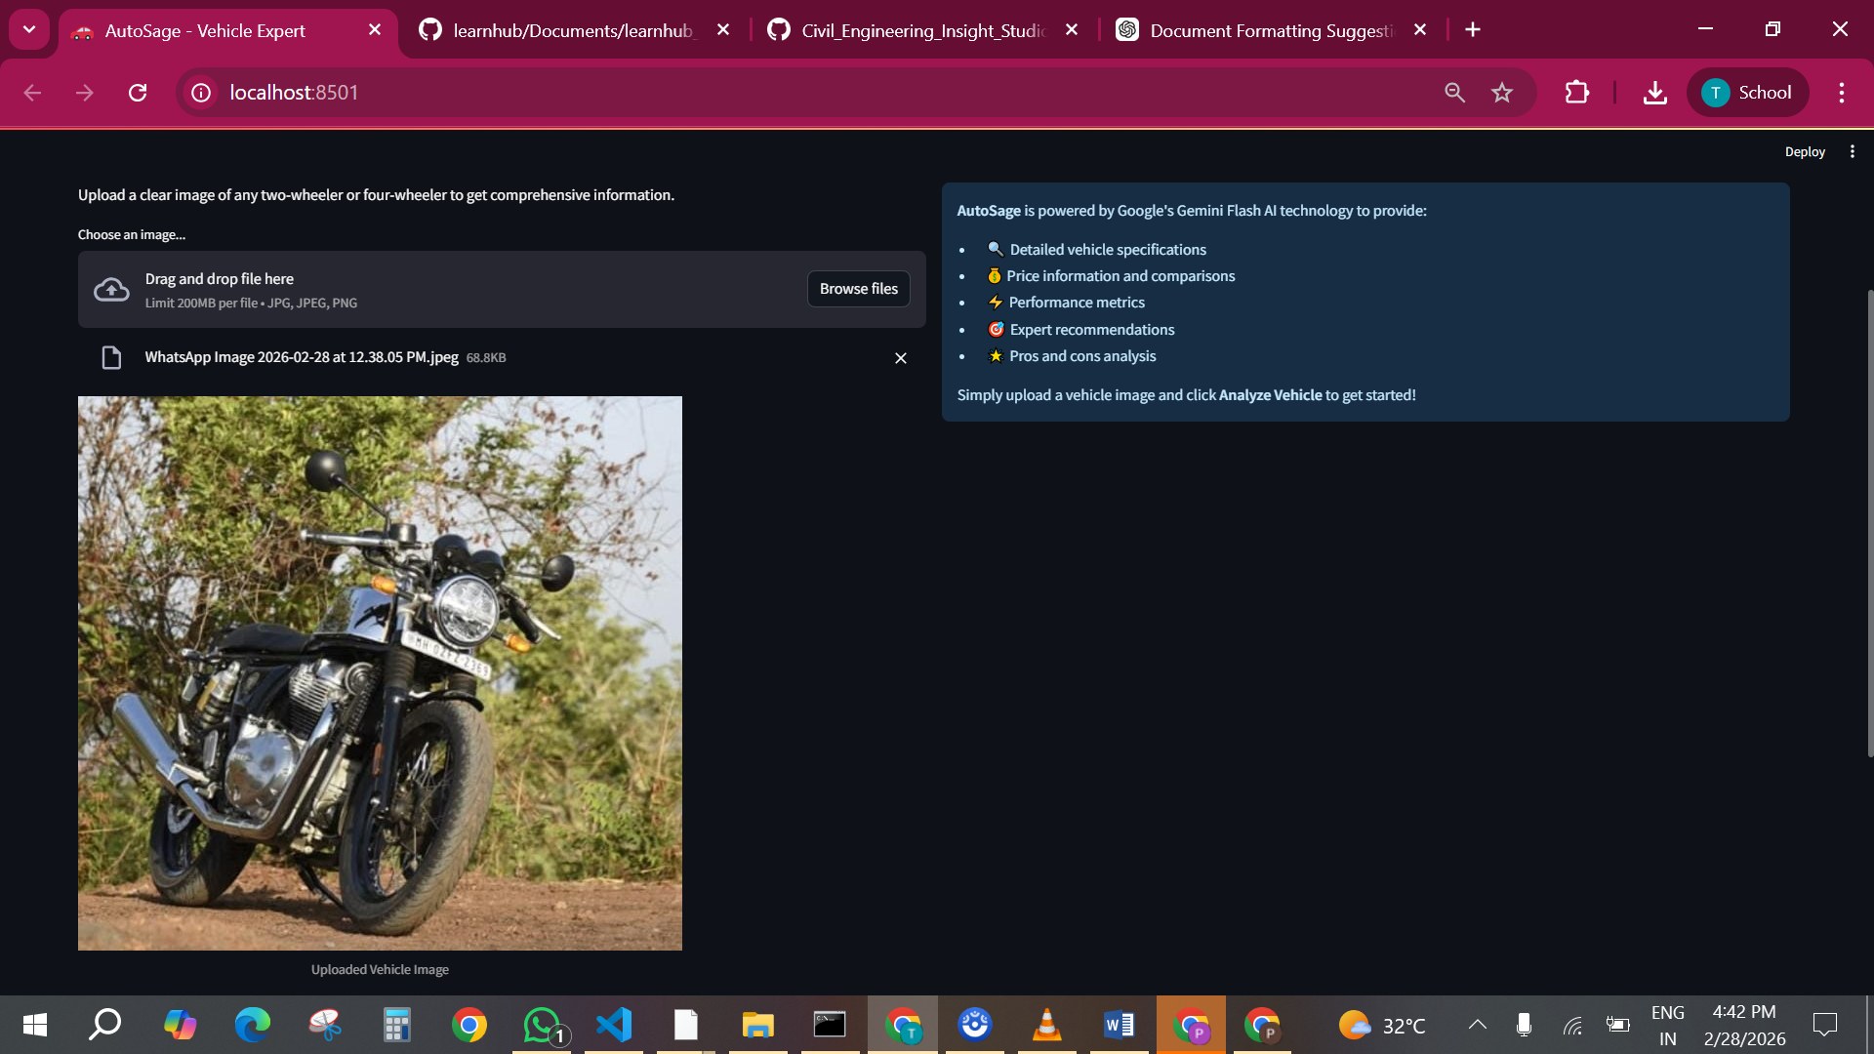
Fig 7.13: Input the image

Step 4: Viewing the Prediction Output
- The predicted insights /reports shown below:
- Screenshot Example:
- 📸 Prediction result shown below the form: " Civil Engineering Insight Studio: Reports "
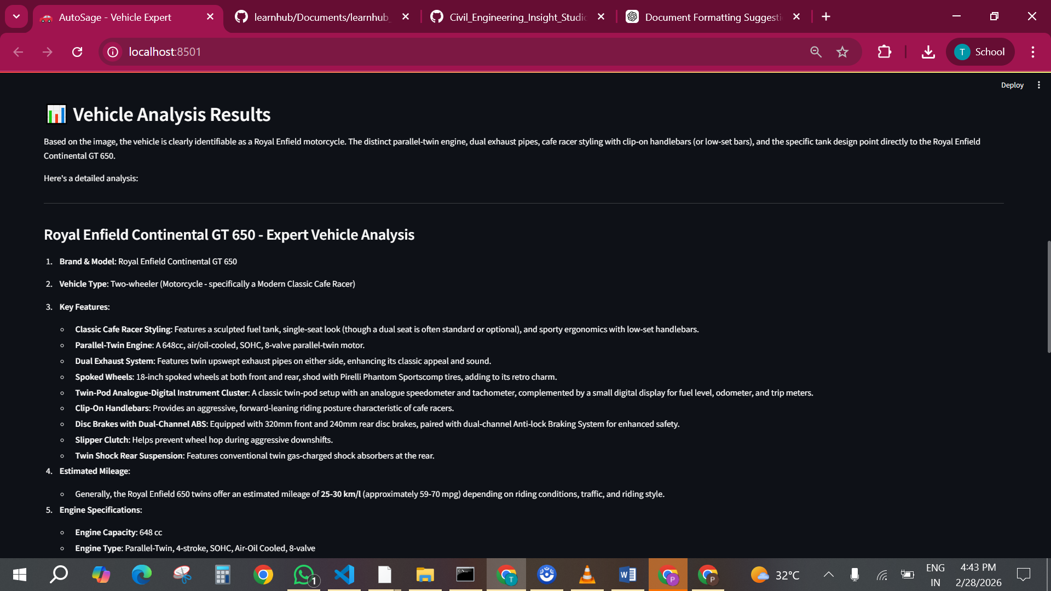

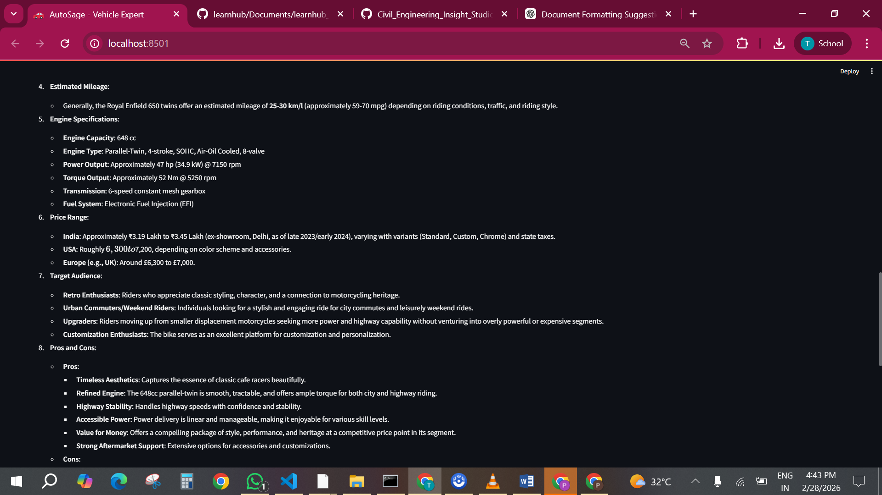
Fig 7.1.4: Predicted Outputs

8. ADVANTAGES & DISADVANTAGES

8.1 Advantages

Improved Decision-Making
Provides AI-driven insights that help users make informed decisions while purchasing two-wheelers and four-wheelers.

Intelligent Vehicle Comparison
Generates side-by-side comparisons based on price, mileage, engine performance, features, and safety ratings.

Personalized Recommendations
Uses Gemini Flash to understand user queries and preferences, offering customized vehicle suggestions.

Time Efficiency
Reduces the need to visit multiple websites by providing centralized, structured vehicle information in one platform.

Eco-Friendly Awareness
Encourages adoption of electric and hybrid vehicles by providing environmental impact insights and efficiency comparisons.

Maintenance Support
Offers seasonal maintenance alerts and service reminders to enhance vehicle safety and longevity.

Scalability
Can be extended to include global vehicle databases, real-time dealership integration, insurance recommendations, and mobile app deployment.

User-Friendly Interface
Designed with a simple and intuitive interface suitable for first-time buyers, experienced vehicle owners, and eco-conscious users.

8.2 Disadvantages

Dependency on Data Accuracy
Incorrect or outdated vehicle data may result in inaccurate comparisons or recommendations.

Internet Dependency
The system requires internet connectivity to access Gemini Flash and real-time vehicle data.

API Dependency
Performance depends on the availability and response speed of the Gemini Flash API.

Initial Development Complexity
Integrating AI-based natural language processing requires proper configuration and testing.

Learning Curve
Some users may need time to understand advanced filtering and comparison features.

Data Maintenance Effort
Vehicle specifications and pricing require regular updates to remain accurate and relevant.

9. CONCLUSION
The AutoSage App Using Gemini Flash provides an intelligent and user-centric platform for vehicle research, comparison, and maintenance guidance. By integrating advanced AI capabilities, the system transforms complex automotive data into simple, actionable insights.
The application enhances purchasing confidence, promotes eco-friendly vehicle adoption, and improves vehicle safety through proactive maintenance alerts.
Future enhancements can include real-time dealership pricing integration, AI-powered loan and insurance recommendations, predictive maintenance features, mobile application deployment, and cloud-based multi-user access. With continuous AI improvements and expanded automotive data integration, AutoSage has the potential to become a comprehensive smart vehicle assistant platform.

10. FUTURE SCOPE
The Civil Engineering Insight Studio project can be enhanced using AI/ML for prediction and real-time monitoring. Future scope includes BIM/CAD integration, cloud deployment, and smart infrastructure planning. However, there are several opportunities to enhance its functionality, scalability, and usability in the future:
- Advanced AI and Machine Learning Integration
The system can be enhanced by incorporating advanced AI and machine learning models to predict structural failures, cost overruns, and project delays. This will improve decision-making accuracy and risk management.
- Real-Time Site Data Integration:
Future versions can integrate real-time data from construction sites using sensors, IoT devices, and monitoring tools to provide live updates on project progress, safety conditions, and material usage.
- BIM and CAD Tool Integration:
Integration with Building Information Modeling (BIM) and CAD software will allow engineers to visualize designs, detect clashes, and perform more accurate simulations within the platform.
- Cloud-Based Deployment:
Deploying the system on the cloud will enable multiple stakeholders to access the platform simultaneously, improve data storage, and support large-scale infrastructure projects.
- Smart City and Infrastructure Planning:
The platform can be extended to support smart city initiatives by analyzing data related to roads, bridges, drainage systems, and urban development, aiding long-term infrastructure planning and sustainability.
- Mobile Application Support:
Developing a mobile application will allow engineers and planners to access insights, reports, and alerts anytime, improving field-level decision-making and coordination.

11. APPENDIX
Source Code:
All codes are submitted in Git-Hub Repository.
Git-Hub Repository Link:
https://github.com/BasheerKhan-Pathan/AutoSage_App_Using_Gemini_Flash
Project Demo Link:

https://drive.google.com/file/d/1LEhSRlqlIfaL-RlWbh79RqBXiVIVz3zc/view?usp=sharing

